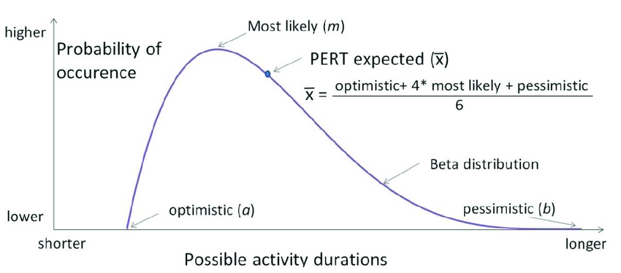
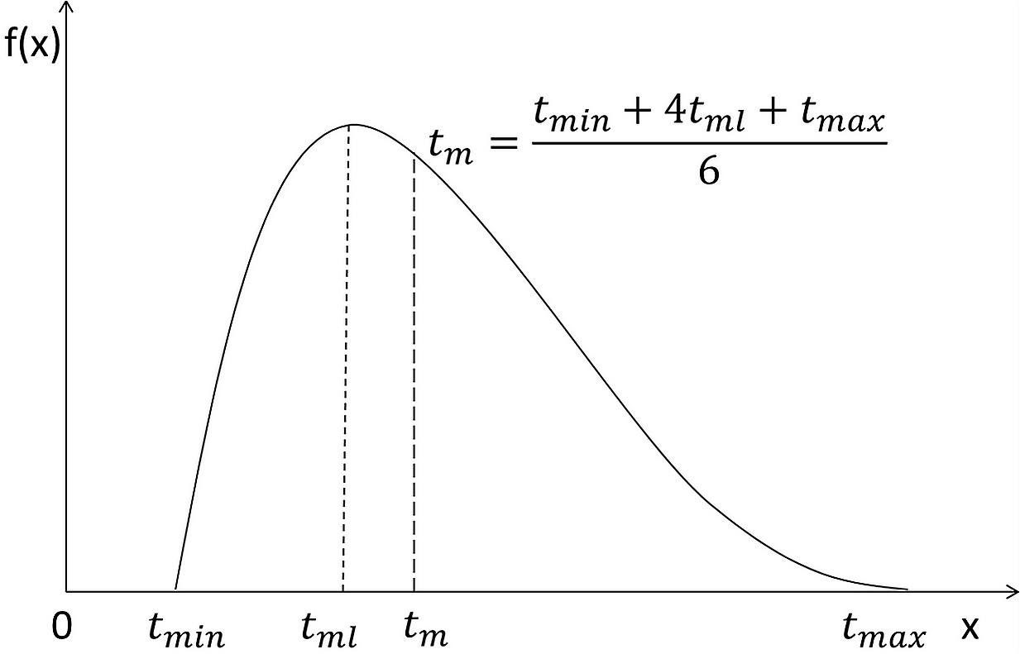
Because project activities usually represent work, and because work tends to stay behind once it gets behind, the PERT developers chose an approximation of the beta distribution to represent activity durations. The activity durations can be skewed more toward the high or low end of the data range.

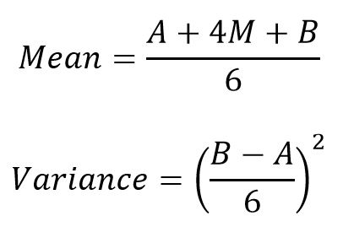
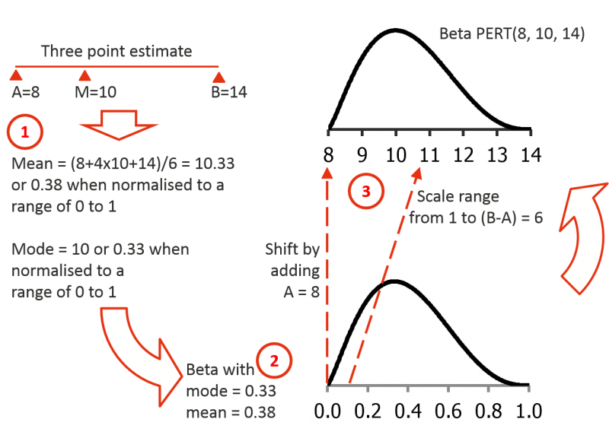

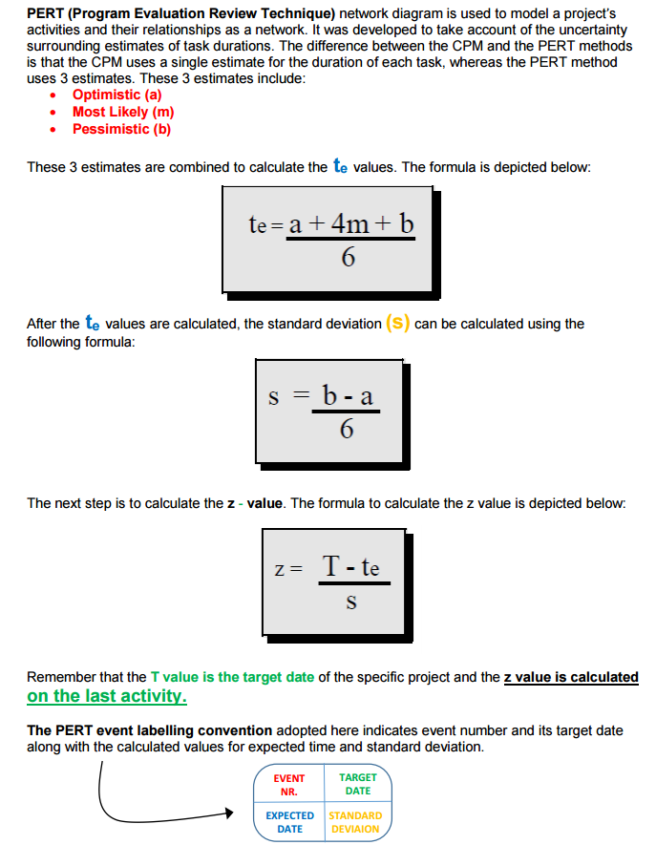

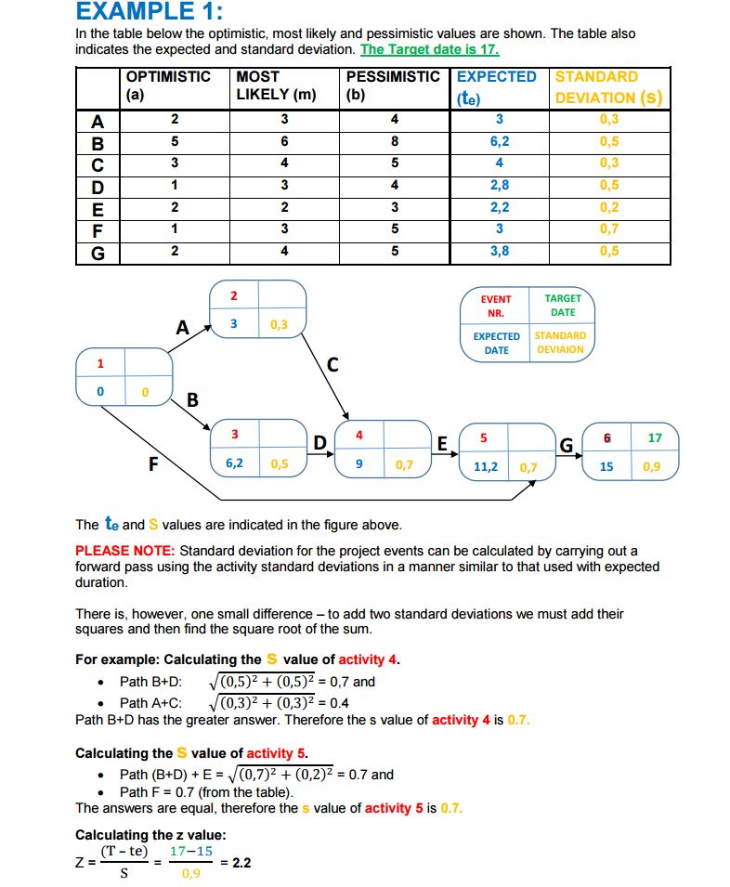

The PERT Distribution
The PERT distribution also uses the most likely value, but it is designed to generate a distribution that more closely resembles realistic probability distribution. Depending on the values provided, the PERT distribution can provide a close fit to the normal or lognormal distributions.
Like the triangular distribution, the PERT distribution emphasizes the “most likely” value over the minimum and maximum estimates. However, unlike the triangular distribution the PERT distribution constructs a smooth curve which places progressively more emphasis on values around (near) the most likely value, in favor of values around the edges. In practice, this means that we “trust” the estimate for the most likely value, and we believe that even if it is not exactly accurate (as estimates seldom are), we have an expectation that the resulting value will be close to that estimate.
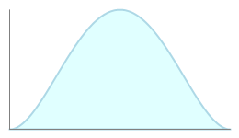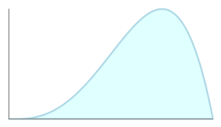
Examples of the PERT distribution: compare the smooth curves to the triangular distribution, above. Values near the peak are more likely than values near the edges.
Assuming that many real-world phenomena are normally distributed, the appeal of the PERT distribution is that it produces a curve similar to the normal curve in shape, without knowing the precise parameters of the related normal curve.

Visual Example
The histograms below demonstrate the PERT distribution and how it compares to a triangular distribution with the same parameters. The λ (lambda) parameter controls the scale of the distribution (the peakedness). Change the values to see the effect on the generated distributions.

https://www.riskamp.com/beta-pert

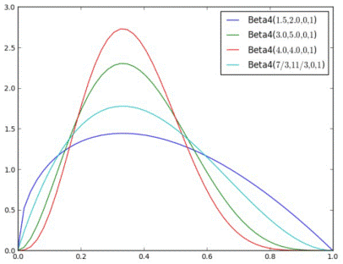

Examples of PERT distribution on the interval [0, 1]
https://www.riskamp.com/beta-pert
z
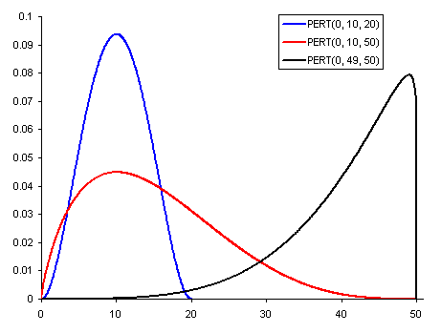

PERT (a, b, c)
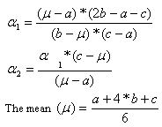

The Mathematical Model
The PERT distribution is a special case of the beta distribution that takes three parameters: a minimum, maximum, and most likely (mode). Unlike the triangular distribution, the PERT distribution uses these parameters to create a smooth curve that fits well to the normal or lognormal distributions.
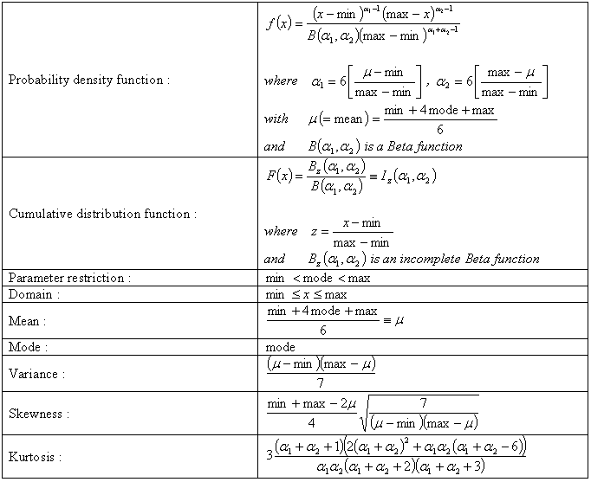

Worksheet Functions
Real Statistics Functions: Excel provides the following functions:
PERT_DIST(x, a, b, c, cum) = the pdf of the PERT function f(x) when cum = FALSE and the corresponding cumulative distribution function F(x) when cum = TRUE.
PERT_INV(p, a, b, c) = x such that PERT_DIST(x, a, b, c, TRUE) = p; i.e. the inverse of the cdf of PERT distribution.
The “divide and conquer” algorithm that calculates PERT_INV uses at most iter iterations (default 200) and stops when the precision of the answer is less than prec (default .0000001). The default values are probably sufficient for most practical use.

Examples
Example 1: Create a plot of the PERT distribution for data with a min of 1, max of 9 and mode of 6. Also, what is the mean and standard deviation of this distribution?
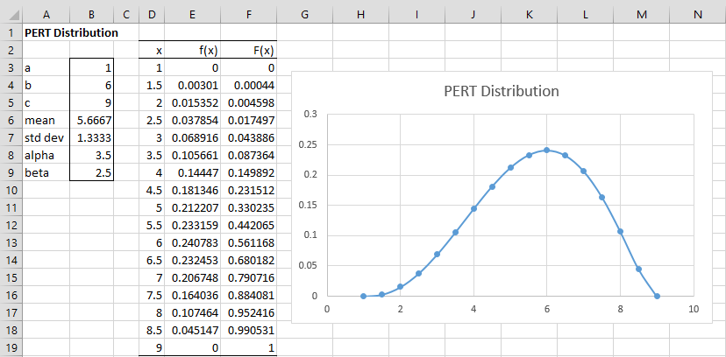
Figure 1 – PERT distribution
From Figure 1, we see that the mean is 5 2/3 (cell B6) and the standard deviation is 1 1/3 (cell B7), as calculated respectively by the formulas =(B3+4*B4+B5)/6 and =(B5-B3)/6, respectively.
The values for alpha (cell B8) and beta (cell B9) are 3.5 and 2.5, as calculated by the formulas =4*(B4-B3)/(B5-B3)+1 and =4*(B5-B4)/(B5-B3)+1.
We create a plot of the distribution from 1 to 9 in .5 increments based on the values in range D3:E19. This is done by placing the formula
=BETA.DIST(P3,$B$8,$B$9,FALSE,$B$3,$B$5)
in cell E3, highlighting the range E3:E19 and pressing Ctrl-D. Alternatively, we could place the following Real Statistics formula in cell E3.
=PERT_DIST(D3,$B$3,$B$4,$B$5,FALSE)
The chart is shown on the right side of Figure 1.
We can also calculate the cumulative distribution function cdf values by placing either of the following formulas
=BETA.DIST(P3,$B$8,$B$9,TRUE,$B$3,$B$5)
=PERT_DIST(D3,$B$3,$B$4,$B$5,TRUE)
in cell F3, highlighting the range F3:F19 and pressing Ctrl-D.
Observation: We can see from Figure 1 that the median of the distribution occurs somewhere between x = 5.5 and x = 6.0. In fact, with a little experimentation, we see that the correct value occurs at about x = 5.74524. This can be verified using the formula =PERT_INV(B3,B4,B5).

